Tucana Class Summer Term 5 2026
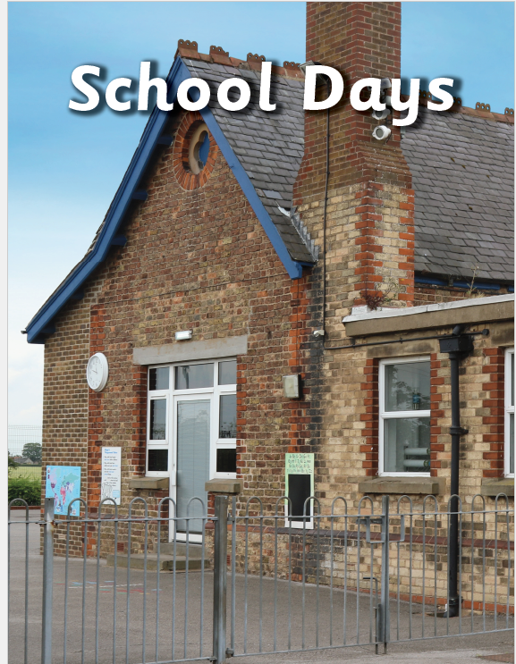
In the School Days project, your child will have the opportunity to take part in a traditional Victorian class and will learn about the differences between schooling in the Victorian era and schooling today. They will learn about objects found in a Victorian classroom and how they were used. They will research Samuel Wilderspin, an important figure in the development of schooling for young children in the Victorian era, whose ideals are reflected in schooling today. They will learn to describe the passage of time through study of past, present and future tense vocabulary.
Maths | Developing understanding across three key areas: money, fractions, and time. Recognise different coins and notes and practise counting amounts in both pence and pounds. How to choose the correct coins and notes to make given amounts, compare different values, and calculate totals. Exploring parts and wholes, including equal and unequal parts. Recognise and find fractions such as halves, quarters, and thirds. Learn about months and days, as well as hours, minutes, and seconds. Telling the time to o’clock, half past, and quarter past the hour.
English | Fictional writing, descriptive settings, writing instructions. We will using the following books; The Wolf Who Wouldn’t Go to School, The Extraordinary Gardener and The Disgusting Sandwich.
History | This topic allows us to learn more about the past, specifically the Victorian era. We will be building on our knowledge of past, present and future by sequencing events in chronological order on timelines. We will be focussing on Queen Victoria, people’s lives in the Victorian era, new inventions and school life. This topic allows us to compare and contrast school life now and Victorian schools. We will learn about the lessons, classrooms, teachers and even punishments! We will explore how schools have changed, we will also discover Samuel Wilderspin, learning how he changed school life for children.
D&T | Learn about food and where it comes from. Explore how different foods are sourced and begin to understand that some foods need to be prepared before they can be eaten.  Design and make their own sandwich, following a simple design brief. Think carefully about their ingredients and create a design that meets a given criteria. Learn how to use equipment safely and follow important food hygiene rules.
Art | Artwork depicting streets views and buildings as well as 3D murals.
PE | In the first part of the summer term, the focus is on fitness and cricket skills.
Science | Find about plants and how they grow. Identify, compare, group and sort a variety of common wild and garden plants, including deciduous and evergreen trees, based on observable features. Understand how plants grow from seeds or bulbs, and that a bulb contains a tiny plant with the food it needs to grow. Use simple equipment, with support, to take measurements and make observations as part of their learning. Explore why plants are important to both humans and animals, and investigate how plants change across the seasons.
Computing | Programming – moving a robot. In this unit of computing, we will be using our directional skills to move robots using new programming skills. We will learn what each command does and use that knowledge to star predicting the outcome of programs.
Music | Having Fun with Improvisation: Improvising is fun! It’s an exciting activity where everyone is creating something new. It can be a melody or a rhythm. When you improvise, you can do it on your own or in groups. In this unit, we ask, ‘What Songs Can We Sing to Help Us Through the Day?’ while learning songs we can use throughout the day like ‘Brush out Teeth’ and ‘Get Ready’. We will be exploring tempo, beat, pitch and notes expanding on our previous knowledge.
RE | Children will be exploring the question, “Are some stories more important than others?” They will look at a range of Old Testament stories and discuss what lessons can be learned from them.
PSHCE | Children will be following the Jigsaw unit on “Relationships.” Learn about how to build healthy and positive relationships with others, including the importance of sharing and cooperating. Begin to identify some of the things that can cause conflict and explore ways to manage these situations. This learning will support children in developing strong social skills and positive connections with others

