Sparkle and shine Cygnus Class Autumn Term 2 2025
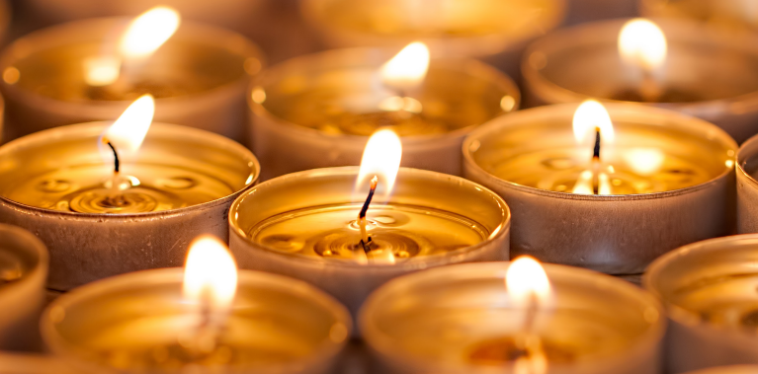

In the Sparkle and Shine project, your child will explore different celebrations that take place in autumn and winter, focusing on the significance and symbolism of light at this time of year. They will take part in a variety of creative activities and discover more about how Christmas, Diwali, Eid and Hanukkah are celebrated around the world.
Areas of learning: Understanding the World
Memorable experience | Celebrations
Innovate challenge | Making tealight holders / diwas
Communication and language | Listening: attention and understanding: Speaking
Physical development | Gross motor skills: Fine motor skills
Personal, social and emotional development | Self-regulation: Managing self: Building relationships
Literacy | Comprehension: Writing
Mathematics | Number: Numerical patterns
Understanding the world | Religions, cultures and festivals – Eid, Ramadan, Hanukkah, Diwali, Christmas. Food tasting.
Expressive arts and design | Creating with materials including paint, clay, felt, tissue paper, cardboard, junk modelling and decoupage. Making Rangolis, menorahs, poppies, prayer mats.  Being imaginative and expressive; role play Rama and Sita, nativity

Supporting your child at home
- Talk about special events that you celebrate at home.
- Share photos of events that you celebrate.
- Talk about how you prepare for special celebrations including the clothes you wear, food you prepare and gifts you give or receive.

