Pupil premium strategy statement – St Peter’s CE School, 24/25-26/27end
Before completing this template, read the Education Endowment Foundation’s guide to the pupil premium and DfE’s pupil premium guidance for school leaders, which includes the ‘menu of approaches’. It is for school leaders to decide what activity to spend their pupil premium on, within the framework set out by the menu.
All schools that receive pupil premium are required to use this template to complete and publish a pupil premium statement on their school website by 31 December every academic year.
If you are starting a new pupil premium strategy plan, use this blank template. If you are continuing a strategy plan from last academic year, you may prefer to edit your existing statement, if that version was published using the template.

Before publishing your completed statement, delete the instructions (text in italics) in this template, and this text box.

This statement details our school’s use of pupil premium funding to help improve the attainment of our disadvantaged pupils.
It outlines our pupil premium strategy, how we intend to spend the funding in this academic year and the outcomes for disadvantaged pupils last academic year.

School overview – 25/26
Detail | Data
Number of pupils in school | 97
Proportion (%) of pupil premium eligible pupils | 4%
Academic year/years that our current pupil premium strategy plan covers (3-year plans are recommended – you must still publish an updated statement each academic year) | 24/25-26/27 end  This is year 2 – 25/26 and 24/25 review
Date this statement was published | November 25
Date on which it will be reviewed | November 26
Statement authorised by | Diane Axford
Pupil premium lead | Diane Axford
Governor / Trustee lead | John Turberville

Funding overview
Detail | Amount
Pupil premium funding allocation this academic year | £21.820
Pupil premium funding carried forward from previous years (enter £0 if not applicable) | £0
Total budget for this academic year  If your school is an academy in a trust that pools this funding, state the amount available to your school this academic year | £21820

Part A: Pupil premium strategy plan

Statement of intent
The intention of our pupil premium strategy is to support disadvantaged pupils to achieve that goal, including progress for those who are already high attainers. We will consider the challenges faced by vulnerable pupils they do not prevent access to high quality teaching, and can make good progress and achieve high attainment across all subject areas. We intend to achieve our vision of all pupils We aim for everyone to be nurtured in order that they can reach their full potential and so flourish, achieve and live fulfilled lives and this strategy supports us to achieve this.
High-quality teaching is at the heart of our approach, with a focus on areas in which disadvantaged pupils require the most support. This is proven to have the greatest impact on closing the disadvantage attainment gap and at the same time will benefit the non-disadvantaged pupils in our school. It is our the intention that non-disadvantaged pupils’ attainment will be sustained and improved alongside progress for their disadvantaged peers.
Our strategy is also integral to wider school plans for education enrichment, notably in its support for social and emotional wellbeing. Our approach will be responsive to common challenges and individual needs, rooted in robust diagnostic assessment, not assumptions about the impact of disadvantage. The approaches we have adopted complement each other to help pupils excel.
To ensure they are effective we will:
• ensure all pupils, including disadvantaged, are challenged in the work that they’re set
• act early as soon as need is identified
• adopt a whole school approach in which all staff have knowledge and take responsibility for disadvantaged pupils’ outcomes, including wellbeing, and raise expectations of what they can achieve.

Challenges
This details the key challenges to achievement that we have identified among our disadvantaged pupils.
Challenge number | Detail of challenge
1
  Assessments indicate that rates of progress and attainment in writing including spelling among disadvantaged pupils is below that of non-disadvantaged pupils.
2 | Our observations and discussions with pupils and families have identified social and emotional issues for many pupils due to their circumstances. These challenges particularly affect disadvantaged pupils, including their attainment and wellbeing.
3 | Our observations show us that familial relationships experience difficulty from time to time and need support including specialist and from wider professional services
4
  Approximately 40% of disadvantaged pupils have SEND which means specific approaches to support these pupils may include explicit instruction, cognitive and metacognitive strategies, scaffolding, flexible grouping, and the targeted use of technology is necessary.
5
  About 60% of our pupils are higher attaining and need sustained challenge to ensure they are reaching their full potential.
6 | Our service pupils experience uncertainty and academic interruption with periods of deployment and relocation.

Intended outcomes
This explains the outcomes we are aiming for by the end of our current strategy plan, and how we will measure whether they have been achieved.
Intended outcome | Success criteria
That pupils achieve in line with their non-disadvantaged peers, especially | KS1 and 2 data shows that disadvantaged pupils achieve similar percentages to non disdvanatged peers in each category (WTS, EXS, GD)
  in writing and spelling.
That all groups including SEND and more able more able disadvantaged pupils achieve in line with their non-disadvantaged peers. | KS1 and 2 data shows that disadvantaged pupils achieve similar percentages to non disdvantaged peers in each category (WTS, EXS, GD)
That SEMH needs are met by qualified and experienced people and practice, meaning better access to learning and therefore progress and attainment. | Pupil, staff and parent voice shows pupils feel safe and able to regulate. Intervention tracking and assessment (QCA, Boxall) shows positive impact of interventions
That service pupils’ collective and individual needs are met. | Surveys and attainment data show SPP pupils achieve as well as non SPP.
  Parents feel well supported and able to access support when needed.
  Parent and pupil voice report high levels of pastoral support as appropriate
  Parent voice shows parents are positive and well supported

Activity in this academic year
This details how we intend to spend our pupil premium funding this academic year to address the challenges listed above.

Teaching (for example, CPD, recruitment and retention)
Budgeted cost: £6500

Activity | Evidence that supports this approach | Challenge number(s) addressed
Professional development T&L on evidence-based approaches  - • Attendance on the writing project run by Trust  - • Consultant time to develop plan for high quality writing texts  - • Writing CPD and moderation time for all staff  - • EYFS video CPD x 3 | https://www.dropbox.com/s/oldaulzaybik4c0/DGT%20Full%20report.pdf?dl=0  https://www.dropbox.com/s/2c8r7y1ohhm39ba/35pdk_97_7.pdf?dl=0  https://www.dropbox.com/s/obcuwhhyvp2hi5p/eef-a-review-of-educational-interventions-and-approaches-informed-by-neuroscience.pdf?dl=0  Writing practice review | EEF
 | https://d2tic4wvo1iusb.cloudfront.net/eef-guidance-reports/supporting-parents/EEF_Parental_Engagement_Guidance_Report.pdf?v=1635355222  Fostering Belonging, Transforming Schools: The Impact of Restorative Practices | Learning Policy Institute  https://www.dropbox.com/s/mns8kd14qxh2rdm/can-teachers-
  Professional development SEMH on evidence-based approaches
  - • Participate in relational schools programme and circles training
  - • Embed zones of regulation training
  - • Growing Great People initiative
  - •

Targeted academic support (for example, tutoring, one-to-one support, structured interventions)
Budgeted cost: £ 9000
Activity | Evidence that supports this approach | Challenge number(s) addressed
 | Literacy | EEF  Spelling Shed - Spelling Shed - The Science of Spelling | 1,2,4,5
  Spelling shed purchased to improve spelling scores
  Highly trained Ta to deliver small group writing intervention
  Small group intervention focused on improving progress in English and SEMH
  Literacy | EEF
  https://educationendowmentfoundation.org.uk/education-evidence/teaching-learning-toolkit/small-group-tuition
  Selecting_interventions_tool.pdf
  https://educationendowmentfoundation.org.uk/education-evidence/teaching-learning-toolkit/small-group-tuition
  https://educationendowmentfoundation.org.uk/education-evidence/guidance-reports/primary-sel
  1,4,5
  1,2,4,5,6
1:1 tuition for SEND pupils to close gaps and provide learning in the most suitable style.
  Special Educational Needs in Mainstream Schools | EEF
  https://educationendowmentfoundation.org.uk/education-evidence/teaching-learning-toolkit/one-to-one-tuition
  1,2,4

Wider strategies (for example, related to attendance, behaviour, wellbeing)
Budgeted cost: £ 6500
Activity | Evidence that supports this approach | Challenge number(s) addressed
 | Supporting Service Children in School: An Organisational Improvement Framework, iCeGS, University of Derby | SCiP Alliance  Thriving Lives Toolkit: enhancing school collaboration | SCiP Alliance  https://www.scipalliance.org/research/listening-to-learn-the-voices-of-service-children
  Forces lead time to meet with pupils and complete activities/trips/meet with families and organise partnership school activities
 | Arts participation | EEF  Full article: The Hare and the Tortoise go to Forest School: taking the scenic route to academic attainmen
  Resources and staffing to support outdoor education programme all classes x 10 sessions a year
 | Nursing paths in research: therapy dogs in CAMHS  Complementary Psychosocial Interventions in Child and Adolescent Psychiatry: Pet Assisted Therapy – PMC  People living in families with disabled children are more than twice as likely to be living in poverty than those in families where no-one was Disabled (Dept of Work and Pensions report Jan 2024). In addition, 53% of families claim that having a disabled child causes some/major relationship difficulties or breakups (source: About Families), which is considerably higher that the population in general, suggesting that there could be a link between being an additional needs parent, levels of poverty and family breakup
  Therapy dog reading/writing/SEMH sessions
  Home School Link Worker

Total budgeted cost: £ 22000

Part B: Review of the previous academic year

Outcomes for disadvantaged pupils
Attainment Summer 2 24-25
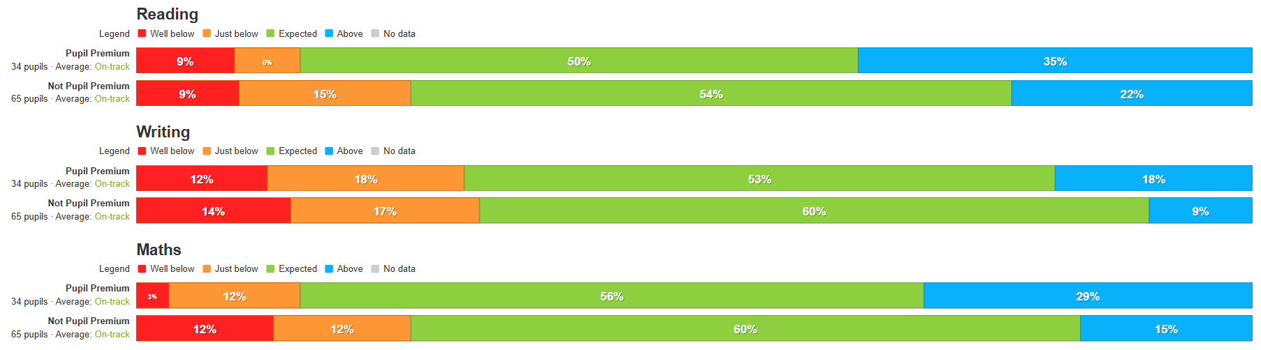
.Attendance 24-25
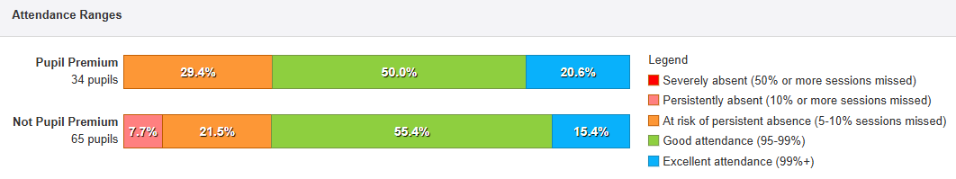
85% of pp pupils attended extra curricular activities
94% of y1 passed phonics screening check
Average Y4 MTC score above national average (22/25)
No suspensions or exclusions for PP pupils
Pupil voice shows high level of contentment and self esteem
19 behaviour incidents in the 24-25 year for pp (34 pupils) vs 78 for non pp (65) therefore non pp have a lower than expected record of incidents.

Service pupil premium funding (optional)
For schools that receive this funding, you may wish to provide the following information: How our service pupil premium allocation was spent last academic year
Forces Lead employment to support pastoral care and family deployment
Coach and staff funding to attend trips/visits
Resources to support living as part of military family and for non-military families
The impact of that spending on service pupil premium eligible pupils
This provided support for managing the individual needs of the child and helping them to make good progress over the course of the year and to feel safe and heard.

